Project 2: Your Surrounding World

Jonathon Moore

CST-310

College of Engineering: Software Engineering

Professor Citro

GitHub Link: <https://github.com/hydrenoid/CST-310>

Project 2: Your Surrounding World

1. A description of the project

The aim of this project is to enhance our observational skills and technical abilities by engaging in 3D modeling and rendering of everyday scenes. By choosing three distinct scenes from our surroundings, we will explore the intricate geometrical characteristics, colors, and textures of common objects and settings, and translate these into detailed OpenGL renderings. The scope of this project will be to select three different scenes such as a dorm room, cafeteria, pool, etc. that are not too complex that rendering would be too difficult, while also making sure they are not too trivial as to not be a challenge. This first project will be setting up future projects where we will make full renderings and graphics for the subsequently chosen scene.

1. A description of the methodology/approach used

For this project I decided to look locally as where I live has many different scenes available to me. For my first scene I chose my living room, as it contains geometrical objects that would be easier to render, ie. TV, coffee table, couches, end table, however these objects get complex when you try to add in windows and the lighting coming through it as well as multilayered objects like the entertainment center and the coffee table, on top of this the couches are curved in some areas so to represent it truthfully will take merging of different primitives to get the desired shape. For my second scene I chose my backyard as it is a bit more open with natural lighting, while still providing some good regular objects that can be rendered. On top of those objects this scene introduces a larger background with bushes and trees that will add complexity to the project as a whole, while also adding in a little bit of houses in the background. For my third scene I wanted to focus more on the background as a whole so I used my car in the front parking lot as the foreground and made sure that the background had a lot going on in it. From trees far away to houses the depth that is created would add an interesting twist to a scene, using the z-axis as much as possible, and making depth rendering crucial. On top of this the lighting from the background objects makes it a bit more difficult as the natural lighting is not uniform with some of the trees. Through all of these scenes they offer a good balance between normal objects, as well as complex ones. Each scene becoming as detailed or complex as the creator wishes.

1. Six JPG or PNG images, two per scene

Livingroom:

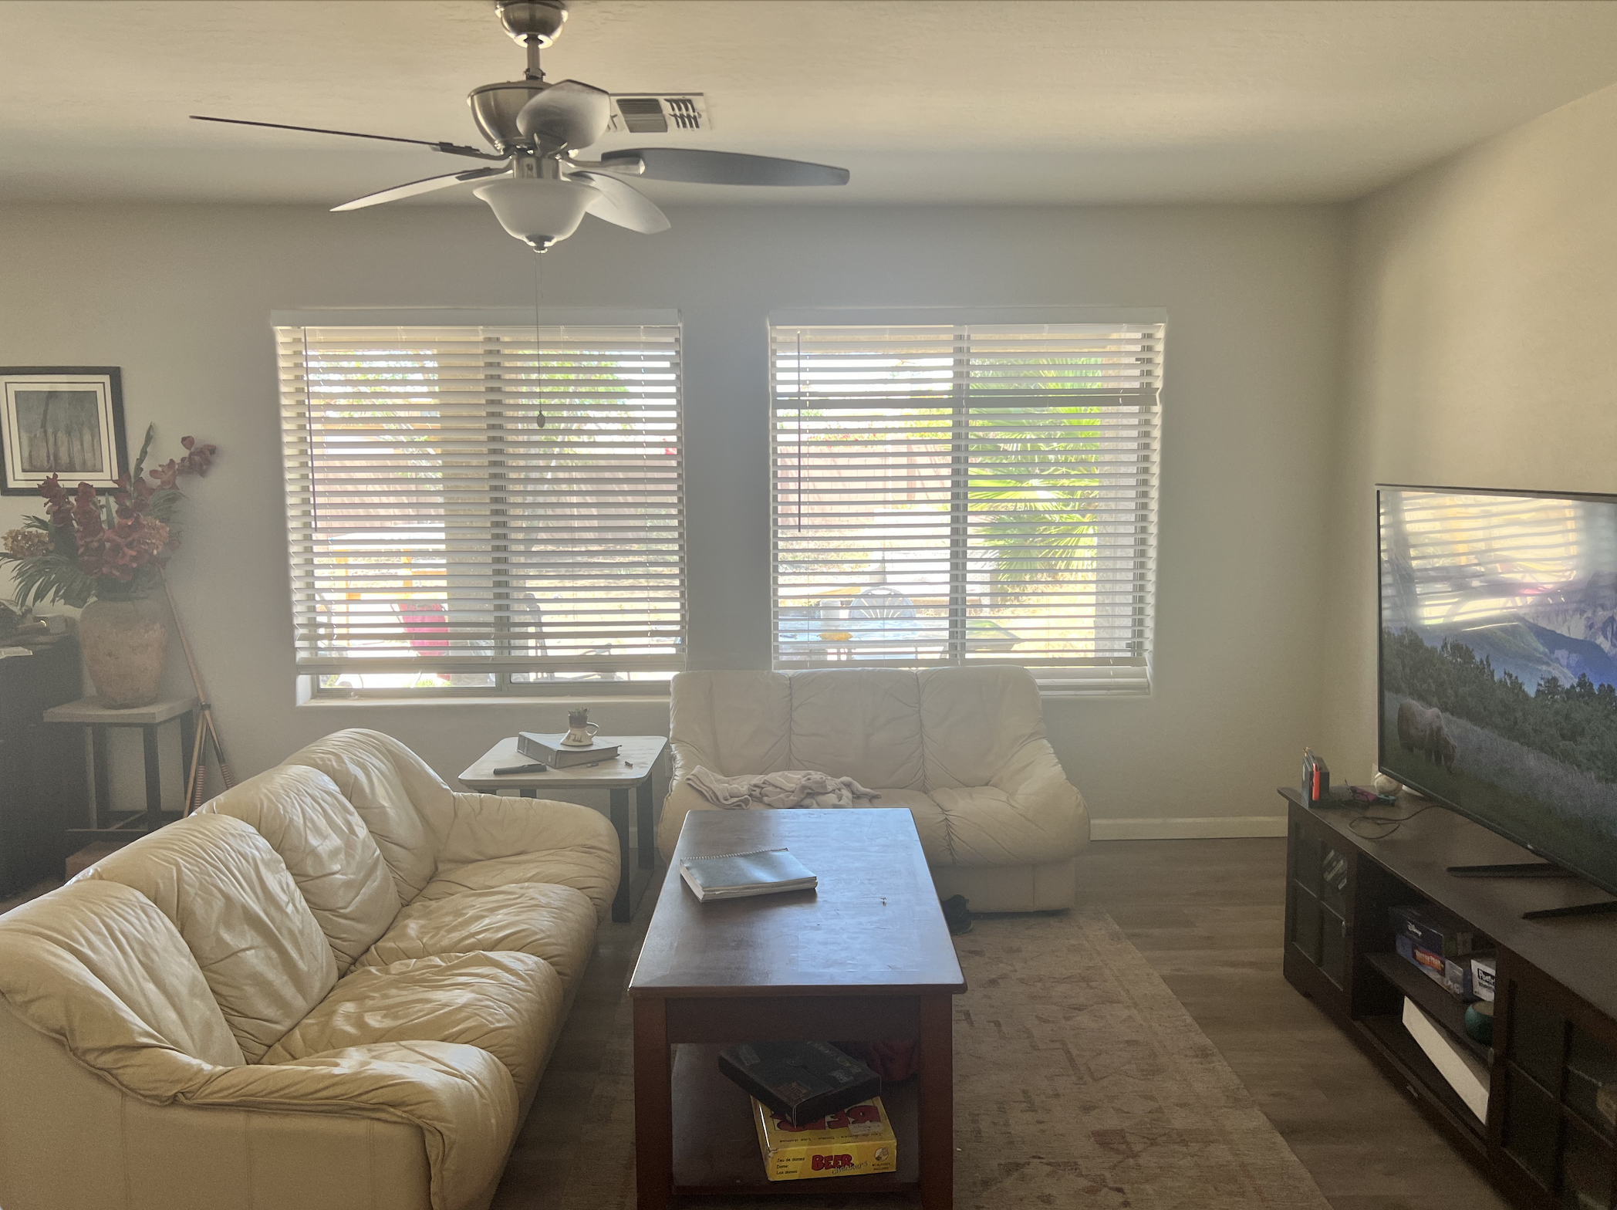

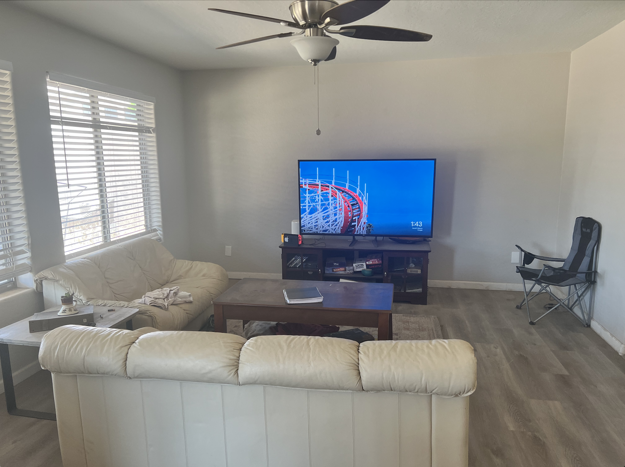

Backyard:

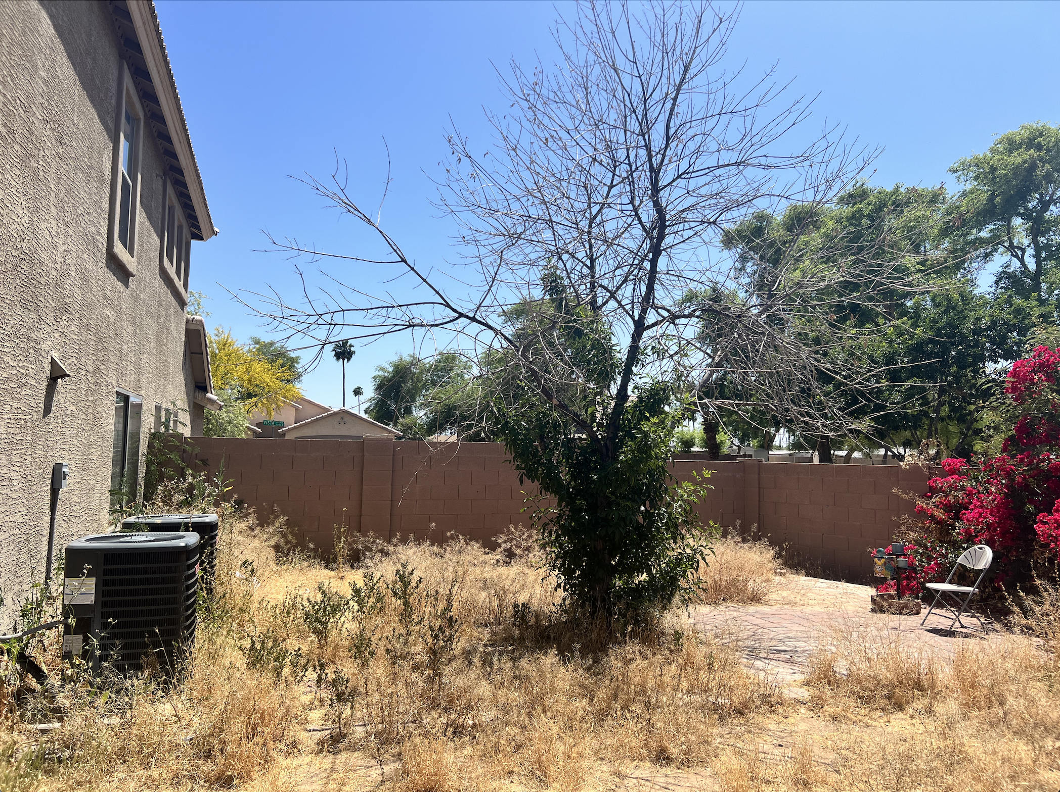

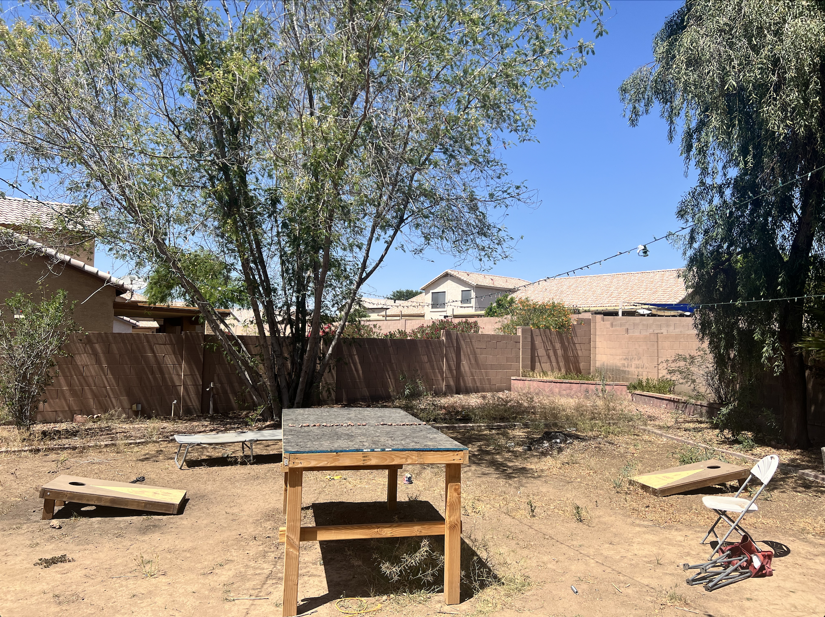

Neighborhood:

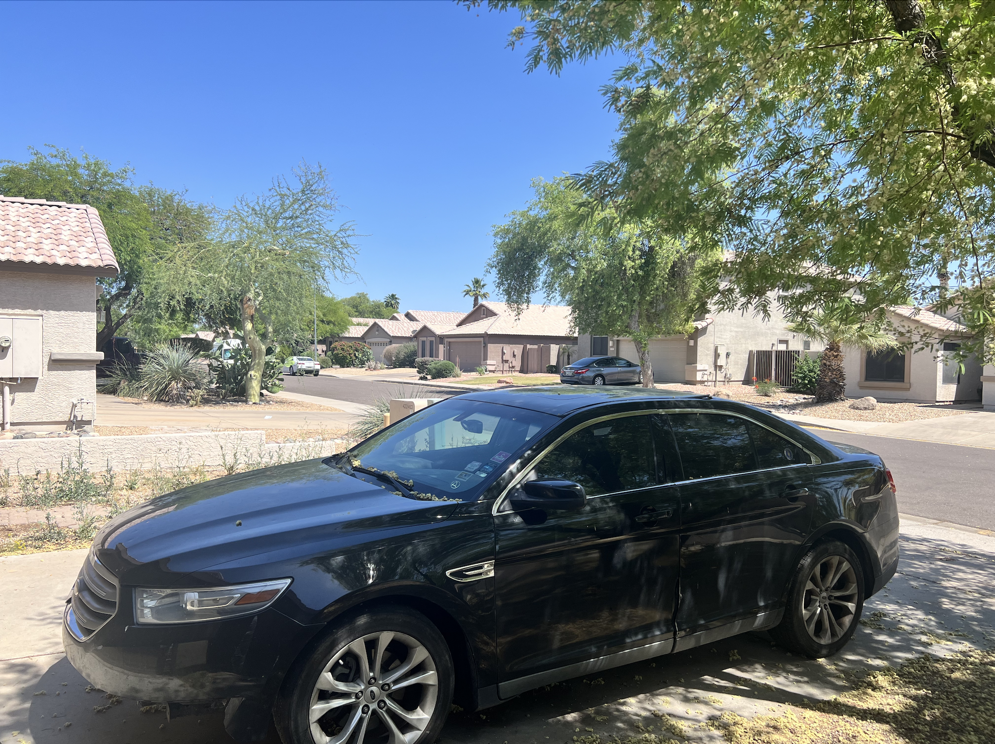

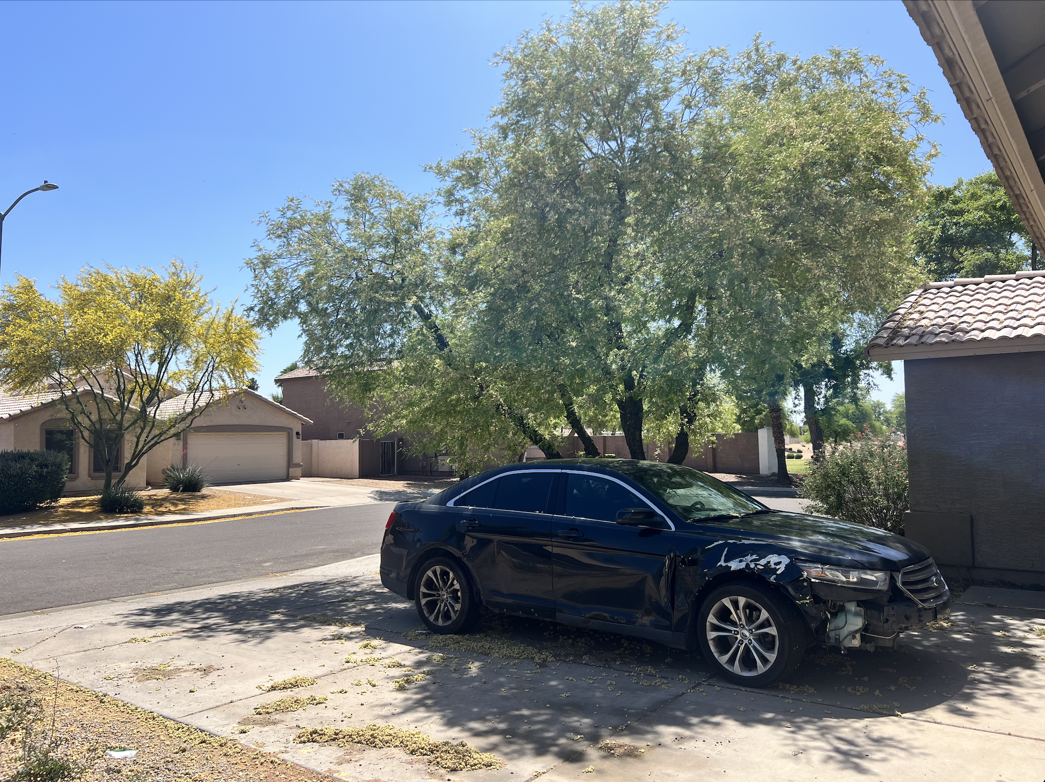

1. Statement of authenticity

5/8/2024

I, Jonathon Moore, took these six pictures with my own camera by myself. They are created by me and only me solely for this class and project. They are not downloaded from the internet or any other source.

